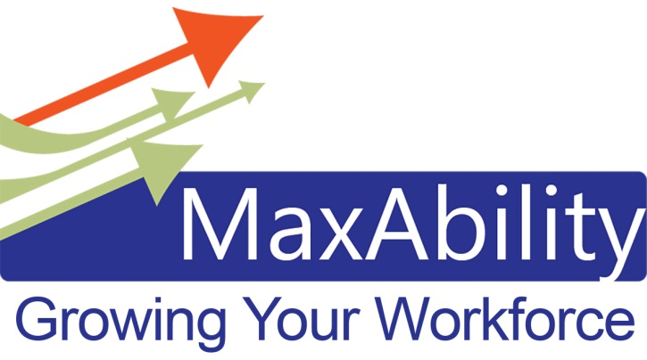
Mission Statement: To maximize career success for people with employment barriers and develop opportunities for businesses to meet hiring needs.

Three Key Strategies:
- Four Network Meetings a Year - Southern Minnesota Disability Employment Network (SMDEN). These network meetings will provide an avenue for employers, job placement professionals, non-profit professionals, and educators to learn together, partner together, collaborate together…all in the effort to grow competitive employment opportunities for people with disabilities; and put all available skills to work.
  - 2018 SMDEN Dates:
    - February 14 – Culture First: Building An Inclusive Workplace Workshop
Disability Awareness to increase your Comfort, Confidence, and Competence
    - April 25 – Inclusive Recruiting Workshop
Learn best practices for interviewing people with disabilities and participate in mock interviews
    - June 20 – Workplace Mental Health: Creating a Stress-Free Culture
Panel Discussion
    - August 15 – Inclusive Culture Success Stories
Featuring staffing solutions that meet your business needs
  - All meetings are from: 8:30 – 10:30 a.m.
  - Location: Woodlake Meeting Center, 210 Wood Lake Drive SE, Rochester
- Annual Job and Resource Fair. MaxAbility Presents: Career Connections…A Career Fair and Education Event. This event will allow employers, educators, job placement coaches, and applicants to connect face-to-face and discuss job opportunities. This event will take place on October 4, 2018 at the Canadian Honker Events Center. The program begins at 9:00 a.m.
- Membership and Marketing. We will be proactively recruiting employers to join our efforts as well as proactively marketing our mission and effort. This will only work if employers engage in the conversation and make a commitment. This outreach to employers needs to be deliberate and intentional.

The MaxAbility mission is connected to the Olmstead Plan: Embraces the Olmstead decision as a key component of achieving a Better Minnesota for all Minnesotans, and strives to ensure that Minnesotans with disabilities will have the opportunity, both now and in the future, to live close to their families and friends, live more independently, engage in productive employment, and to participate in community life. This includes:
- The opportunity and freedom for meaningful choice, self-determination, and increased quality of life, through: opportunities for economic self-sufficiency and employment options; choices of living location and situation, and having supports needed to allow for these choices;
- Systemic change supports self-determination, through revised policies and practices across state government and the ongoing identification and development of opportunities beyond the choices available today;
- Readily available information about rights, options, risks, and benefits of these options, as well as the ability to revisit choices over time.

To Join MaxAbility and/or a MaxAbility subcommittee, contact:
Guy Finne, HR Manager – Mayo Clinic: finne.guy@mayo.edu
Dawn Kirchner, Diversity Recruitment Specialist – Mayo Clinic: kirchner.dawn@mayo.edu

